

2012 Promotional Examination II
Pre-university 2

MATHEMATICS 8864

Paper 1 11 September 2012

3 hours
Additional Materials: Answer Paper

List of Formulae (MF 15)

READ THESE INSTRUCTIONS FIRST

Write your name and class on all the work you hand in.
Write in dark blue or black pen on both sides of the paper.
You may use a soft pencil for any diagrams or graphs.
Do not use paper clips, highlighters, glue or correction fluid.

Answer all the questions.
Give non-exact numerical answers correct to 3 significant figures, or 1 decimal place in the case of angles in degrees, unless a different level of accuracy is specified in the question.
You are expected to use a graphic calculator.
Unsupported answers from a graphic calculator are allowed unless a question specifically states otherwise.
Where unsupported answers from a graphic calculator are not allowed in a question, you are required to present the mathematical steps using mathematical notations and not calculator commands.
You are reminded of the need for clear presentation in your answers.

At the end of the examination, arrange your answers in NUMERICAL ORDER and fasten all your work securely together.

The number of marks is given in brackets [ ] at the end of each question or part question.
Section A: Pure Mathematics [35 marks]

1 | (a) | Without using a calculator, solve the simultaneous equations  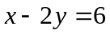 and 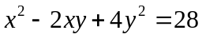. | [3]
 | (b) | Find the range of values of for which 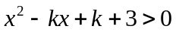 for all real values of . | [3]
2 | Using a non-calculator method, find the coordinates of all the stationary points of the curve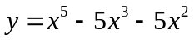 . Determine the nature of each of the stationary points, showing your working clearly.  Sketch the curve. |  | [5]  [1]
3 | Sketch, on separate diagrams, the graphs of the following equations, clearly stating the equations of any asymptotes and the coordinates of any points where the graphs cross the axes:
 | (i) 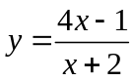, |  | [3]
 | (ii) 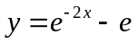. |  | [3]
4 | P  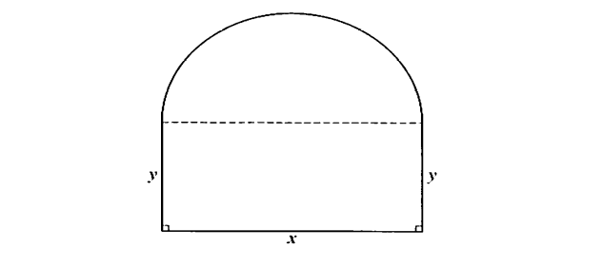  The diagram shows a piece of wire bent to form the perimeter of the plane shape PQRSTP which consists of a semicircle and a rectangle. The diameter of the circle is cm and 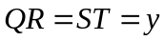cm. The length of the wire is 50 cm and the area of the plane shape PQRSTP is 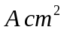. Show that 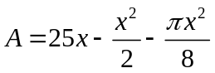.  Q  T  R  S  Without using a calculator, find the maximum value of  as varies. |  | [3]  [5]
5 | (a) | (i) Find 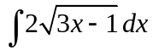, | [2]
 |  | (ii) Without using a calculator, evaluate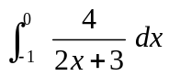. | [3]
 | (b) | On the same diagram, sketch the curve 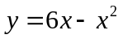 and the line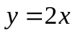. Find the exact area of the region enclosed by the curve and the line . | [4]
Section B: Statistics [60 marks]

6. | A wholesaler sells a particular brand of cookies in packets. The mass of a packet of cookies is normally distributed with mean 900 g and standard deviation 40 g. 98% of the packets have a mass which exceeds the ‘guaranteed’ mass.
 | (i) | Find the ‘guaranteed’ mass to the nearest gram. | [2]
 | A random sample of 100 packets of cookies is selected.
 | (ii) | Find the probability that the mean mass of a packet of cookies is less than 894 g. | [2]
7. | Amy and Benny are conducting a survey with 60 students at a particular school which comprises of 3 pre-university (PU) levels of 1200 students, to collect data on the amount of time students spend on internet each day.
 | (i) | Amy decides to choose the first male students and the first female students she sees at the assembly area. What name is given to this type of sampling? | [1]
 |  | State one disadvantage of this sampling method in the context of the question. | [1]
 | (ii) | Describe how Benny may select 60 students using systematic sampling, and state an advantage of this sampling method. | [3]
 | (iii) | Describe an alternative sampling method that would give a better representation of each level, given that there are 500 PU1 students, 400 PU2 students and 300 PU3 students. | [3]
8. | A factory produces components for an electrical product. 3% of the components that the factory makes are defective. The components are packed in boxes each containing 24 components.
 | (i) | Find the probability that a randomly selected box contains
 |  | (a) at most three defective components, | [1]
 |  | (b) at least one defective component. | [2]
 | (ii) | Find the probability that of five randomly selected boxes, each contains at least one defective component. | [1]
 | A customer buys 100 boxes of components. Using a suitable approximation, find the probability that less than 50 boxes will each contain at least one defective component. |  | [4]
9. | The following table shows the mathematics marks obtained in the Mid Year Examination (x) and the marks obtained in the Final Examination (y) by a group of students.
Student | A | B | C | D | E | F | G | H | I
x | 16 | 32 | 71 | 41 | 51 | 65 | 46 | 38 | 27
y | 29 | 50 | 75 | 63 | 78 | 80 | 65 | 54 | 43

 | (i) | Calculate the product moment correlation coefficient for this set of data. | [1]
 | (ii) | Give a sketch of the scatter diagram for the above data as shown on your calculator. | [2]
 | (iii) | Calculate the equation of the regression line of y on x, and the equation of the regression line of x on y. Sketch the regression line of y on x on your scatter diagram.
 |  |  | [3]
 | (iv) | A tenth student obtained a mark of 10 in the Mid Year Examination. Using the appropriate regression line, estimate the mark that this student would obtain in the Final Examination. Comment on the reliability of your answer.
 |  |  | [3]
10. | A factory manufactures batteries for a particular model of mobile phone. The factory owner claims that the mean standby-time of the batteries is 36 hours. A random sample of 90 batteries is tested and the standby-time, x hours, is measured. The results are summarised by 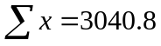 and 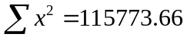.
 | (i) | Find the unbiased estimates of the population mean and variance.
 |  |  | [3]
 | (ii) | Test at the1% significance level whether the population mean standby-time is less than 36 hours.
 |  |  | [4]
 | (iii) | State, giving a reason, whether it is necessary to assume a normal distribution for the test to be valid.
 |  |  | [1]
 | (iv) | State the set of values of level of significance for which the null hypothesis will be rejected. | [1]
11 | A set of 30 cards is made up of cards chosen from a number of packs of ordinary playing cards. The numbers of cards of each type are given in the following table.
   | Spades | Hearts | Diamonds | Clubs
  King | 2 | 5 | 3 | 5
  Queen | 4 | 3 | 6 | 2
(a) One card is taken at random from the set. Events H and K are defined as follows.
H: The card taken is a Heart.
K: The card taken is a King.
 | (i) | Describe in words what the event 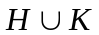 represents and state the probability of this event. | [2]
 | (ii) | Describe in words what the event 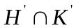 represents and state the probability of this event. | [2]
 | (b) Two cards are taken from the set, at random and without replacement. Find the probability that exactly one card is a King. |  | [2]
 | (c) Three cards are taken from the set, at random and without replacement. Find the probability that they are at least two Kings. |  | [4]
12 | (a) | (i) Given that 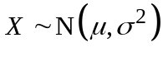 and 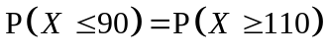, find .  (ii) Given also that 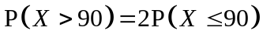, find . | [1]  [3]
 | (b) | The masses, in kilograms, of papayas and melons have independent normal distributions. The papayas have a mean mass of 1.4 kg and a standard deviation of 0.2 kg. The melons have a mean mass of 1.2 kg and a standard deviation of 0.3 kg.  Three papayas and a melon are chosen at random. Find the probability that the total mass of the three papayas exceeds twice the mass of the melon by at least 1kg.  Papayas cost $2 per kg and melons cost $3 per kg. Find the mean and the variance of the total cost of three papayas and two melons and hence find the probability that the total cost is between $16 and $21. | [4]  [4]
End of Paper

